Gear Example:

1. Intent of the application is to find defects on the gear like the one shown in the image:

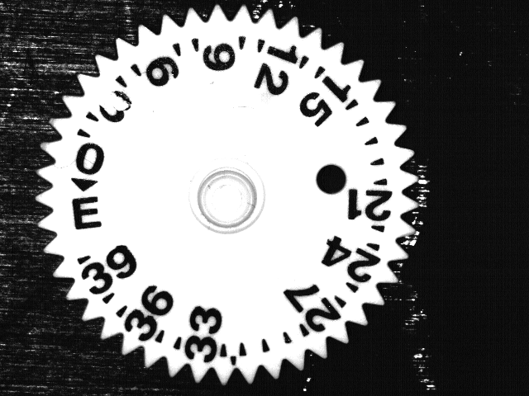

1. First step is to create the fixture
2. Next step is to train on Gear001.bmp to create the TrainFlawModel. Make sure to use an annulus that helps not train on the inner circle at the center of the part.
3. Next step is to create a Flex. Since these images have a number of enclosed segments, we will use enclosed segment flex of 10 for this example. So set flex to custom and enclosed segment flex to 10.
4. Next step is to detect Flaw. Set Area Defects to Both and no Edge defects.